线性回归和逻辑回归实验指导书
姓名 章栋杰
学号 226001033
学院 阳明学院
专业班级 计算机2班
一：实验目的
通过编程，从实践的角度，提高对线性回归和逻辑回归的理解，特别是利用梯度下降求解逻辑回归的过程。
二：实验环境
需要安装的库：
- python3.6+
- numpy
- matplotlib
- sklearn
- pandas
三：实验内容
- 用sklearn框架利用线性回归实现预测西瓜成熟度任务；
- 用sklearn框架利用逻辑回归实现分类西瓜好坏任务；
- 用python(自己实现，不用框架)实现梯度下降法求解2中任务。（选做）

四：实验步骤
- 导入依赖包

2. 导入数据集

3. 划分训练集和验证集

4. 使用线性回归对训练集进行训练/使用逻辑回归对训练集进行训练

5. 对验证集进行预测

6. 预测结果与验证集的label进行对比，计算其均方误差

五：参考代码
linear_model.py:
#encoding=utf-8
import sklearn
import matplotlib.pyplot as plt
from sklearn import model_selection
from sklearn import linear_model # 导入线性回归模型
from sklearn import metrics # 导入模型度量
import xlrd # pip install xlrd==1.2.0
import pandas as pd
import numpy as np
"""
--------xxxx--------
"""
import pandas as pd
from matplotlib import pyplot as plt
from sklearn import model_selection, linear_model, metrics

excel_name="./西瓜成熟度.xlsx"
data=pd.read_excel(excel_name)

x=data[data.columns[1:3]].values
y=data[data.columns[3]].values

x_train,x_test,y_train,y_test=model_selection.train_test_split(x,y,test_size=0.1,shuffle=True)

L=linear_model.LinearRegression()
L.fit(x_train,y_train)

y_train_predict=L.predict(x_train)

# plt.plot([i for i in range(len(y_train_predict))],y_train_predict)
# plt.plot([i for i in range(len(y_train))],y_train)
# plt.show()

y_test_predict=L.predict(x_test)
print(y_test_predict)
print(y_test)
err=metrics.mean_squared_error(y_test_predict,y_test)
print(f"测试集损失为:{err}")
print(L.coef_)

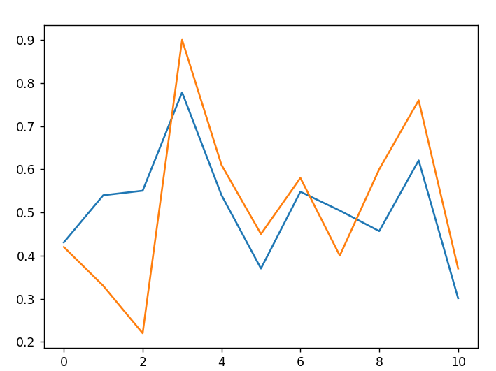
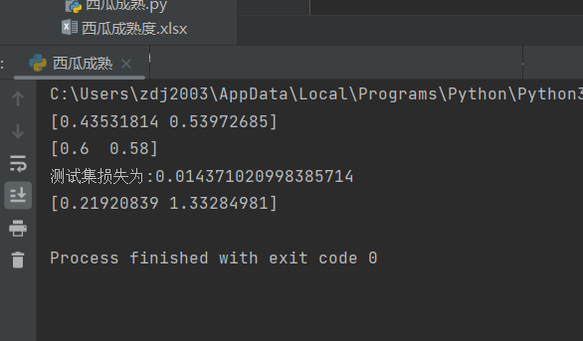
logistic_regression.py:
#encoding=utf-8
import sklearn
import matplotlib.pyplot as plt
from sklearn import model_selection
from sklearn.linear_model import LogisticRegression
from sklearn import metrics # 导入模型度量
import xlrd # pip install xlrd==1.2.0
import pandas as pd
import numpy as np

import pandas as pd
from sklearn import model_selection
from sklearn.linear_model import LogisticRegression

excel_name="./西瓜好坏.xlsx"
data=pd.read_excel(excel_name)
#.value产生的数据类型为array
x=data[data.columns[1:3]].values
y=data[data.columns[3]].values

x_train,x_test,y_train,y_test=model_selection.train_test_split(x,y,test_size=0.1,shuffle=True)

L=LogisticRegression()
L.fit(x_train,y_train)

y_predict=L.predict(x_test)
print(y_predict)
print(y_test)

sgd_logistic_regression.py: （选做）
#encoding=utf-8
import pandas as pd
import numpy as np

import numpy as np

import pandas as pd
from sklearn import model_selection
from sklearn.linear_model import LogisticRegression
class LogisticRegressionGD:
def __init__(self, learning_rate=0.01, n_iterations=1000):
self.learning_rate = learning_rate # 学习率
self.n_iterations = n_iterations # 迭代次数
self.weights = None # 权重
self.bias = None # 偏置

def sigmoid(self, z):
# Sigmoid函数
return 1 / (1 + np.exp(-z))

def fit(self, X, y):
n_samples, n_features = X.shape # 样本数量和特征数量
self.weights = np.zeros(n_features) # 初始化权重
self.bias = 0 # 初始化偏置

# 梯度下降
for _ in range(self.n_iterations):
linear_model = np.dot(X, self.weights) + self.bias # 计算线性模型
y_predicted = self.sigmoid(linear_model) # 计算预测值

# 计算梯度
dw = (1 / n_samples) * np.dot(X.T, (y_predicted - y)) # 计算权重的梯度
db = (1 / n_samples) * np.sum(y_predicted - y) # 计算偏置的梯度

# 更新参数
self.weights -= self.learning_rate * dw # 更新权重
self.bias -= self.learning_rate * db # 更新偏置

def predict(self, X):
linear_model = np.dot(X, self.weights) + self.bias # 计算线性模型
y_predicted = self.sigmoid(linear_model) # 计算预测值
y_predicted_cls = [1 if i > 0.5 else 0 for i in y_predicted] # 将概率值转换为类别
return np.array(y_predicted_cls) # 返回预测类别

if __name__ == '__main__':

excel_name="./西瓜好坏.xlsx"
data=pd.read_excel(excel_name)
#.value产生的数据类型为array
x=data[data.columns[1:3]].values
y=data[data.columns[3]].values

x_train,x_test,y_train,y_test=model_selection.train_test_split(x,y,test_size=0.1,shuffle=True)
model = LogisticRegressionGD(learning_rate=0.01, n_iterations=1000)
model.fit(x_train, y_train)
predictions = model.predict(x_test)
print(predictions)
print(y_test)

六：问答题
在判断西瓜成熟度这个问题上，请解释密度跟含糖量哪个指标更重要？
回答： 密度更重要
依据：因为密度对应的权重参数更大

